virtual encyclopeadia of the bulgarian iconography
Lilia Pavlova-Draganova, Vladimir Georgiev, Lubomil Draganov
Abstract: East-Christian icon art is recognised as one of the most significant areas of the art of painting. Regrettably, it is still being neglected in the digital documentation and the registry of the art of painting. The accessibility to that large part of mankind's cultural and historical ancestry would be enhanced greatly if icons of all possible kinds and origins were digitised, classified, and „exhibited“ in the Internet. That would allow the preservation and even the future digital restoration of a large number of rare specimens of the East-Christian art of painting. This article aims to introduce how modern techniques from the area of digital libraries can be used for implementing the demonstrative multimedia library “Virtual encyclopaedia of the Bulgarian iconography ” , containing a large number of Bulgarian iconic art masterpieces and iconography of various authors, periods and schools.

Keywords: Digital libraries, Multimedia content, Cultural heritage.
ACM Classification Keywords: H.3.7 Digital Libraries – Collection, Dissemination, System issues.

Basic concepts and characteristics of digital libraries with multimedia content
Digital libraries (DL) are a contemporary conceptual solution for access to information archives. The "i2010: Digital Libraries" initiative aims at making European information resources easier and more interesting to use in an on-line environment. The Commission adopted on 30/09/2005 the "i2010: Digital Libraries" communication outlining the vision of this initiative and addressing in particular the issues of digitisation, on-line accessibility and digital preservation of our cultural heritage. [i2010: Digital Libraries, 2005].
According to an informal definition of digital libraries, they are managed collections of information, with associated services, where the information is stored in digital formats and accessible over a network. Digital libraries contain diverse hypertext-organized collections of information (digital objects such as text, images, and media objects) for use by many different users. The collected information is organized thematically and uses hyperlinks that allow the connection between any piece of data and additional data on the same topic. As an addition to the digital objects collection, there are many levels of metadata, indexes, hierarchical links, etc. [Krastev’ ‘05]
The main characteristics of digital libraries are the following:
- Ability to share information;
- New forms and formats for information presentation;
- Easy information update;
- Accessibility from anywhere, at any time;
- Services available for searching, selecting, grouping and presenting digital information, extracted from a number of locations. Using these services depends on the user preferences, needs and wishes of the users, i.e. there is personalization available;
- Contemporary methods and tools for digital information protection and preservation;
- Ability to use different types of computer equipment and software;
- No limitations related to the size of content to be presented.
In the past digital libraries were isolated and monolithic systems limited to access to content of a single provider. The development of the technologies during the last years provides new functionalities and advanced services to contemporary digital libraries such as specialized services for:
- Multi-layer and personalized search, context-based search, relevance feedback, etc.
- Resource and collection management;
- Metadata management;
- Indexing;
- Semantic annotation of digital resources and collection etc.
Three types of digital library architectures are described in [Pavlov at al. ‘05] - hypermedia digital library, Grid-based infrastructure and hyperdatabase infrastructure. They have different complexity. Considering the specific needs and requirements of different cultural and historical heritage projects some of them could be chosen and implemented.
The new digital libraries will provide and manage complex services, processes and workflows on the basis of existing services. It is expected that these services be heterogeneous, autonomous and distributed. The flexibility, the automatic adaptation, the access anywhere and anytime, the decentralization, the wide variety of digital objects and collections, the information security, etc. will be of the some requirements. [Kiernan at al. ‘03] [Pavlov, Paneva ‘05]

“Virtual encyclopaedia of the Bulgarian iconography” - a demonstrator of digital library with multimedia content
Information and multimedia technologies have the potential to make national cultural and historical heritage visible and available for present and future use. The goal of the project “Virtual encyclopaedia of the Bulgarian iconography “ is to develop the information content, structure, and the realisation of a digital library with multimedia content as a demonstrator of “Virtual encyclopaedia of the Bulgarian iconography“. That library includes several hundred specimens of Bulgarian icons from different artists, historical periods, and schools. The chosen architecture represents a hypermedia digital library [Pavlov at al. 05], which means that presentation of a complex multimedia content in the Internet is simplified. The resources are digital objects of different formats – text, graphics, and other media. They are structured in a hypermedia manner, i.e., some digital objects point to other ones. In this way the user can navigate quickly, in a non-linear fashion, within areas of related topics, using the hyperlinks. The digital objects are grouped according to their topics into thematic collections [Pavlov at al. 05]. For each object and collection, special meta-descriptions are created. They include data about the title, the artist, the period (in years and centuries), the school, the dimensions (width/height/thickness), the technique, the base material (type of wood, ground coat, etc) the category, the location, the title description, the author description (biographic data), the comment (icon features such as state, founder’s and other signatures, previous restorations), etc. Also, they contain links to other digital objects and collections, keywords, and so on. That information is used for the semantic annotation and indexing of the digital objects, which facilitate their locating during search requests, and their web-based representation [Paneva at al. ‘05]. A multitude of specialized services for metadata management, content management, indexing, metadata annotation of digital objects and collections, creation of requested document, context-based search, multi-object, multi-feature search, etc, are presented. The “Search” service in the demonstrator aids the visitors in finding a certain object by the following criteria: icon title, author, period, type, school, region and location. The search can be conducted by one as well as by more criteria. Figure 1 depicts the architecture of hypermedia digital library.
WWW browser
User interface
Request
for service
User query

Document
request

Server

Repository

Repository

Repository

Document
request

Available services

Request for specialized service

Specialized service

Digital library with multimedia content

Metadata-annotated digital objects associated with thematic collections: annotated text, annotated images, annotated sound files, annotated video, etc.

Repository
Specialized services for:
metadata management;
content management;
indexing;
metadata annotation of digital object and collection;
creation of requested document;
...
different media types search;
context-based search;
multi-object, multi-feature search;
…

Specialized service
Specialized service
Services
creating a
requested
document

Figure 1: Hypermedia digital library

The organisation of the media databases, the representation and description of the digital objects, and the classification of the artefacts, are developed according to the recommendations of the international group of museum experts of East-Christian Art (UNESCO/I.DB.I) and the standards of CIDOC/MICMO. A lot of work is done on that project for the creation of a high quality interface to a developed multimedia database of several hundred pieces of art of different authors, periods, and schools of the Bulgarian Christian iconography. That group includes painted icons and icons built with mosaics that are located in European museums, churches, monasteries, and private collections.
The mechanisms for protecting the displayed images and textual data from being copied, reproduced and later distributed are conformed to the collections and artifacts owners’ requirements – i.e. the presented digital counterparts of Bulgarian icons are digitally protected with the credit line method, as well as by disallowing the copying and downloading of the images.
The project relies on the idea that the unity of the text information and the high quality of the digital images will represented the virtues of the Bulgarian icon in their entirety and will contribute to the its preservation, wider exhibition, and future potential restoration. The demonstrator that is developed is a tool for exploration of the techniques, styles, colours, and forms, as well as for the tracking and comparing of specimens and periods of the iconography and historical development of that art. [Pavlov at al. ‘05]

System realization of the demonstrator
The objects of the system, their attributes and the relationships between them are shown in the entity-relationship diagram on fig. 2.
Users are those who access the system and use it in various manners. Each user has its unique identifier (id), username, password, email address, first name, last name, and a flag which indicates whether the respective user is the administrator of the digital library. The administrator is the one who has the right to add, remove and edit objects, while the rest of the users are permitted to view them only. In order to gain access to the digital library, the users are required to register for it by specifying a desired username, which has not been already registered, a password, first and last names, and an email address. Upon initial opening of the library’s website, the user is provided with a login box so that he can enter into the system, as long as he has not already done it. After a successful username and password fulfillment, she will have the opportunity to browse the separate sections of the virtual library, until her web browser is closed or until “Exit” is explicitly clicked.
The Object represents an entity of the digital library, which contains data describing a single element. An object has several fundamental characteristics – its title, author, type and main image. Apart from them, it can possess a description, comment, period, technique, base material, dimensions, school, location, region, title description, author description and main image description. The period is comprised of a start and end period and their respective types – exact year or beginning, middle, or end of a century. Additionally, each object can be assigned multiple images, each of which has its own description.

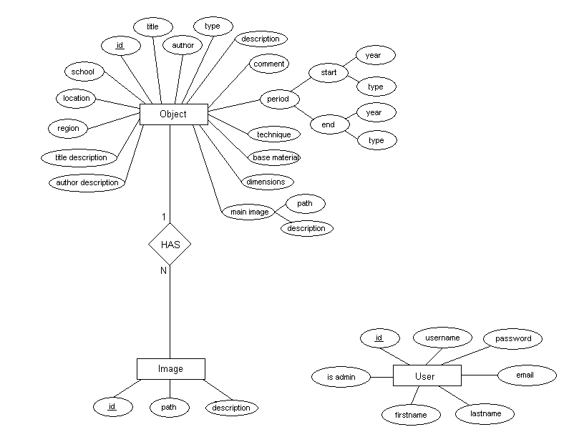
Figure 2: Entity Relationship diagram

After applying standard algorithms of deriving a relational model (which can be directly implemented into a relational database) from an entity-relationship model, three different tables emerged – Users, Objects and Images. The HAS relation between objects and images, which is a “one-to-many” relationship is realized by introducing an extra field objected into the Images table, which is a foreign key pointing to the id of the objects the images are attached to.
The source code of the demonstrator is separated into several scripts, written in PHP and using MySQL for storing the library data, which are executed via web. There are various library files, containing functions used throughout the code, grouped by their purpose, a global CSS file containing the HTML styles defining the user interface, a global JS file containing various JavaScript functions used for enhancing the user interface, and static HTML pages.

Conclusion
This article aims to present digital libraries with multimedia content as a modern technological solution for innovative presentation of the variety of Bulgarian Icon art from different artists, historical periods, and schools. For the past few years the need for a wide accessibility and popularisation of the Bulgarian icons is bigger aiming to disseminate our national cultural and historical heritage. Therefore, it is necessary that the icon’s idiosyncratic art and exceptional values be made available in the global information space, so that they become accessible to both professional researchers and the wide audience. The presented project lays the foundations of the registration, documentation, and the exploration of a practically unlimited number of Bulgarian icons. The tools of the virtual encyclopaedia gives the users the opportunity to compare the icons in their historic context, so that some yet undiscovered treasured of the East-Christian iconography be manifested.

Bibliography
[i2010: Digital Libraries, 2005] "i2010: Digital Libraries“, COM, 465 final, Brussels, 30/09/2005
[Krastev ‘05] Krastev D. (2005), Central Library of Bulgarian Academy of Sciences – present and future, The libraries of Bulgarian Academy of Sciences, Reference book, Bulgaria
[Kiernan at al.’03] Kiernan K., Kekhtyar A. (2003), EPT: Edition Production Technology for Multimedia Contents in Digital Libraries, Presented on Workshop on Multimedia Contents in Digital Libraries, USA
[Paneva at al. ‘05] Paneva D., Pavlova-Draganova L., Draganov L. (2005), Digital Libraries for Presentation and Preservation of East-Christian Heritage, “Generic Issues of Knowledge Technologies”, Proceeding of HUBUSKA Secon Open Workshop, Budapest, Hungary, 75-83pp.
[Pavlov, Paneva ‘05] Pavlov R., Paneva D. (2005), Towards a Creative Exploitation of Digitised Knowledge in eLearning Systems, 2nd CHIRON Workshop, Paris, France
[Pavlov at al. ‘05] Pavlov R., Paneva D., Pavlova-Draganova L., Draganov L. (2005), Digital libraries with multimedia content and applications in Bulgarian cultural heritage (Analytical study), ICT Development Agency, Sofia, Bulgaria

Authors' Information

Lilia Pavlova-Draganova – Laboratory of Telematics, BAS, Sofia, Bulgaria, 8, Acad. G. Bonchev str.; e-mail: lilia@cc.bas.bg
Vladimir Georgiev – Institute of Mathematics and Informatics, BAS, Sofia, Bulgaria, 8, Acad. G. Bonchev str.; e-mail: vlado80@gmail.com
Lubomil Draganov – Institute of Mathematics and Informatics, BAS, Sofia, Bulgaria, 8, Acad. G. Bonchev str.; e-mail: lubo@cc.bas.bg

The digital library “Virtual encyclopaedia of the Bulgarian iconography” is part of the project “Digital libraries with multimedia content and its application in Bulgarian cultural heritage” by contract 8/21.07.2005 between IMI-BAS and State agency for information technologies and communications.

